# What are liquid crystals?

**Advanced Chemistry**

Unit-5

Advanced Polymeric Materials

Liquid crystal is a unique state of matter that has properties between those of conventional liquid and those of solid crystal.

In the crystalline solid state, the constituent molecules occupy specific sites in a three dimensional lattice (positional orders) and points their axes in fixed directions (orientational orders) as illustrated in Figure 1A. Liquid crystal phases which are considered as a true discrete state of matter, possess orientational order (tendency of the molecules to point along a common direction called the director n) and in some cases various degrees of positional molecular orderings in one or two dimensions as shown in Figure 1B and C. On the other hand, in the isotropic liquid state, the molecules move randomly and rotate freely about all possible directions 1D. Thus, liquid crystals (LCs) have been defned as ‘’orientationally ordered liquids’’ or ‘’positionally disordered crystals’’ that combine the properties of both the crystalline (optical and electrical anisotropy) and the liquid (molecular mobility and fluidity) states. This results in the anisotropy of the physical properties (the measured physical properties in different directions will not be the same), which have led to their widespread applications.

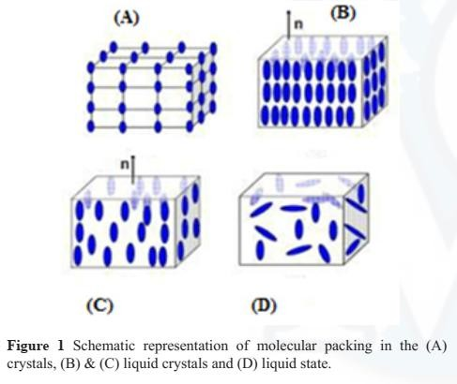

# Describe general classification of liquid crystals?

Liquid crystalline materials are fundamentally divided into two categories, thermotropic and lyotropic mesophases. The term ‘’mesophase’’ originates from the Greek word meso, meaning ‘’in between’’ (the crystal and the liquid phases). Thermotropic liquid crystal phases are obtained by temperature variation, thermodynamically stable mesophases which appear both on heating and cooling are termed enantiotropic, while the thermotropic mesophases that appear only on cooling are monotropic . On the other hand, lyotropic phases form by dissolving a compound in a suitable solvent under a given temperature and concentration. Most of lyotropic mesophases are mixtures, whereas many of the reported thermotropic liquid crystals are single compounds. Some mesogens may exhibit both lyotropic and thermotropic phases; these materials are named amphotropic.

# Write a note on Lyotropic liquid crystal

Compounds forming lyotropic mesophases are amphiphilic which consist of a flexible hydrophobic tail and a polar hydrophilic head group (Figure 3) within the same molecule. Tail is an alkyl chain with 6 to 20 methylene groups in most cases while, the head may be ionic or zwitter ion or non–ionic group as shown in Figure 4.

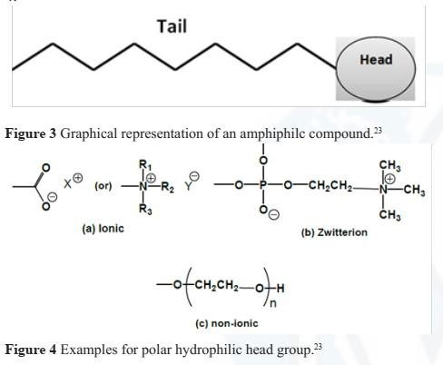

Different lyotropic mesophases can be obtained depending on the molecular structure, solvent, concentration and temperature. Their formation is caused by the separation of the two different parts ((hydrophilic and hydrophobic) of the molecules. At low concentration, the added amphiphilc compounds into a polar solvent form a true molecular mixture because their molecules are dispersed randomly without any ordering. At higher concentration, the molecules are assembled spontaneously and the polar groups occupy the interface towards polar the solvent forming small aggregates with finite size called micelles or vesicles (Figure 5A).

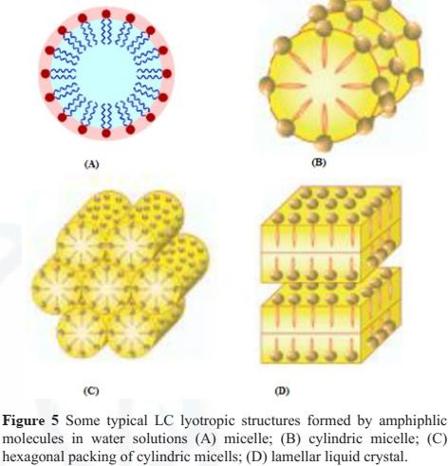

When the concentration of the amphiphilic molecules is further increased, the micelles can turn to disc–like, cylindrical (Figure 5B) and plate–like supramolecular aggregrates which organize themselves forming different mesophases such as nematic, cubic, hexagonal columnar (Figure 5C) and lamellar (Figure 5D). Dissolution of soap in water is the typical example of a lyotropic phase.

# Write a note on Termotropic liquid crystals

Thermotropic LCs has a relatively great attention because they are realized, handled and very important in fabricating display devices. Compounds which have thermotropic liquid crystalline properties do not loss of their long range positional and orientational orders on heating to transform into the isotropic liquid phase spontaneously but rather exhibit a step–wise decay with increasing temperature of the long–range positional order in the first, second or third dimension and finally the long–range orientational order leading to an isotropic melt as shown in Figure 6. This indicate that such compounds do not show a single transition from solid to liquid but rather a series of transitions involving LC phases with the mechanical and symmetry properties intermediate between those of liquid and a crystal.

The thermotropic liquid crystals can be classified in different ways: in terms of their molecular size (as low and high molecular weight compounds), molecular shape of the constituent molecules (calamitic, discotic, sanidic and banana mesogens) and according to the mesophase type (nematic, cholesteric, smectic, columnar, and cubic mesophase etc.)

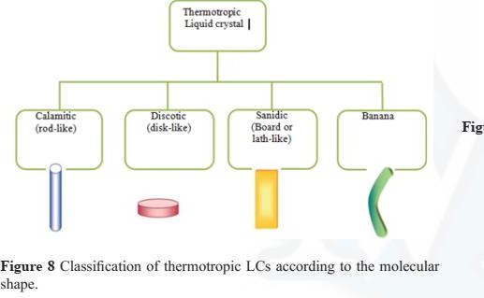

# Describe classification of thermotropic LC with respect to the type of mesophase:

**Write a short note on i) Nematic mesophase, ii) Smectic mesophase and iii) Cholesteric mesophase**

Classification of thermotropic LC with respect to the type of mesophase: Depending on the degree of orientational and positional order of the molecules, the mesophases can be divided into

nematic, smectic, cholesteric, columnar, cubic and bent–core (banana) LC phases. Nematic, Smectic and cholesteric are the most common mesophases.

1. **Nematic (N) mesophase:** In the nematic phase, the molecules have no positional order but, they have long–range orientational order. These molecules are oriented about a particular direction called the director, n as displayed in Figure. This phase occurs just below the isotropic phase but more viscose.

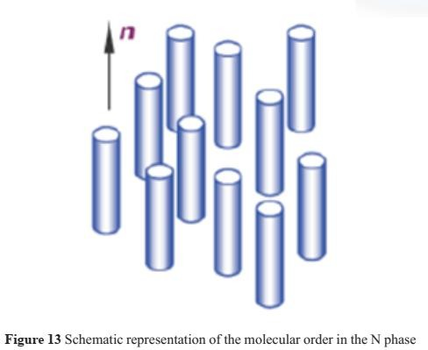

1. **Smectic (Sm) mesophase:** In the smectic mesophases, the molecules are positionally ordered along one direction; therefore, they tend to align themselves in layers or planes. These layers can slide over one another in a manner similar to that of soap. The motion of molecules is restricted to within these planes. This mesophase has more order of molecules than that of the nematic phase so it can be called “solid–like”.

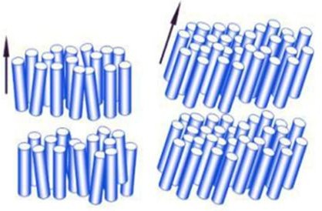

1. **Cholesteric (N*) mesophase:** Cholesteric mesophase consists of nematic mesogenic molecules containing a chiral center; so, it is called as a chiral nematic phase. It can also be obtained by doping optically active molecules in the nematic LC. This type of liquid crystalline phases was first observed in cholesterol derivatives. In this system, the neighboring molecules tend to align at a slight angle at one another. This result in the formation of a structure which can be visualized as a stack of very thin 2–D nematic–like layers with the director in each layer twisted in a regular way with respect to those above and below forming a helix. The molecules are aligned perpendicular to the axis of the helix.

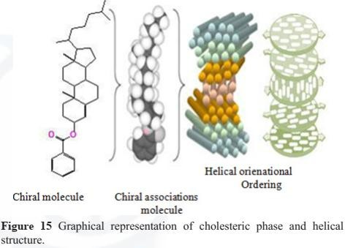

**What are the applications of liquid crystals?**

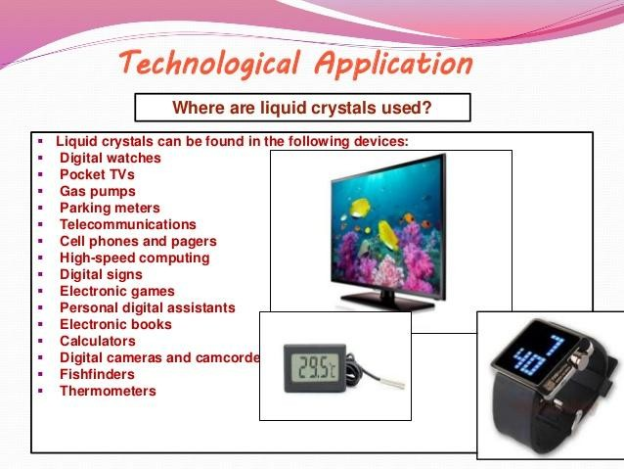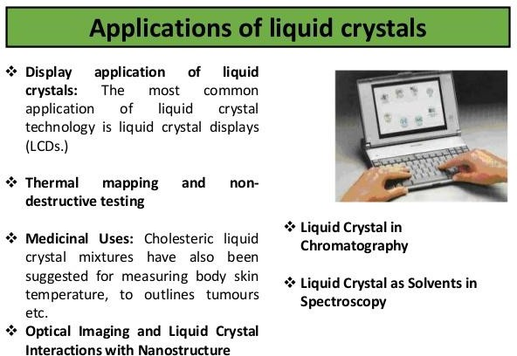

**Write a short note on Liquid Crystal Polymers.**

**What are the properties and applications of Liquid Crystal Polymers?**

Liquid crystalline polymers (LCPs) are a class of materials that combine the properties of polymers with those of liquid crystals.

Liquid crystallinity in polymers may occur either by dissolving a polymer in a solvent (lyotropic liquid-crystal polymers) or by heating a polymer above its glass or melting transition point (thermotropic liquid-crystal polymers). Liquid-crystal polymers are present in melted/liquid or solid form. In solid form the main example of lyotropic LCPs is the commercial aramid known as Kevlar. Chemical structure of this aramid consists of linearly substituted aromatic rings linked by amide groups. In a similar way, several series of thermotropic LCPs have been commercially produced by several companies (e.g., Vectran / Ticona).

# General Properties of Liquid crystal polymers:-

1. A unique class of partially crystalline aromatic polyesters based on p-hydroxybenzoic acid and related monomers, liquid-crystal polymers are capable of forming regions of highly ordered structure while in the liquid phase. However, the degree of order is somewhat less than that of a regular solid crystal.
2. Typically LCPs have a high mechanical strength at high temperatures, extreme chemical resistance, inherent flame retardancy, and good weather ability.
3. Liquid-crystal polymers come in a variety of forms from sinterable high temperature to injection moldable compounds. LCP can be welded, though the lines created by welding are a weak point in the resulting product. LCP has a high Z-axis coefficient of thermal expansion.
4. LCPs are exceptionally inert.
5. They resist stress cracking in the presence of most chemicals at elevated temperatures, including aromatic or halogenated hydrocarbons, strong acids, bases, ketones, and other aggressive industrial substances.
6. Hydrolytic stability in boiling water is excellent. Environments that deteriorate the polymers are high-temperature steam, concentrated sulfuric acid, and boiling caustic materials.

# Describe various applications of Liquid crystal polymers:- Applications of Liquid crystal polymers:-

1. Because of their various properties, LCPs are useful for electrical and mechanical parts, food containers, and any other applications requiring chemical inertness and high strength.
2. LCP is particularly attractive for microwave frequency electronics due to low relative dielectric constants, low dissipation factors, and commercial availability of laminates.
3. Packaging Microelectromechanical Systems (MEMS) is another area that LCP has recently gained more attention